**CS5573 SAIJYOTHI GUDIBANDI**

**Lab Assignment – 2 16233204**

Description:

In this assignment, you will gather live systems information, open ports and services of a victim system.

Questions:

1. List the **live systems** that are reachable to your system (1 point)

Ans: command:

**nmap sP 192.168.1.114/24**

192.168.1.114-my systems address.

Outputs:

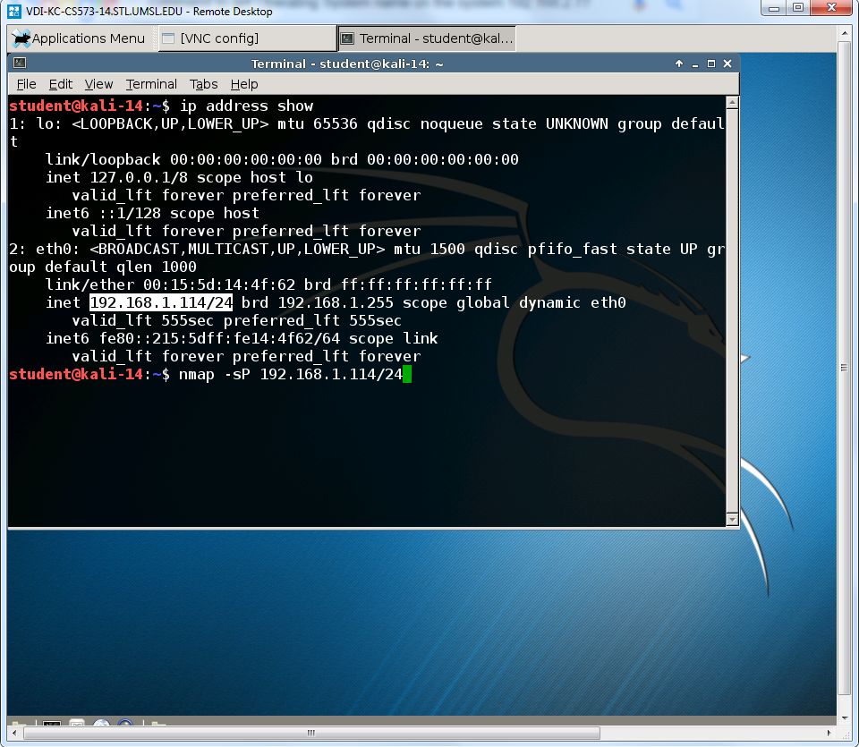

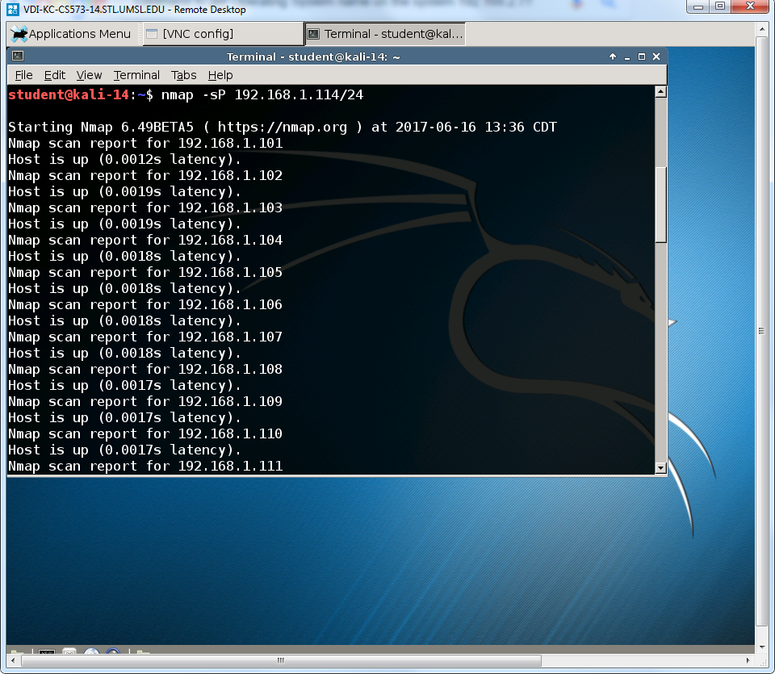

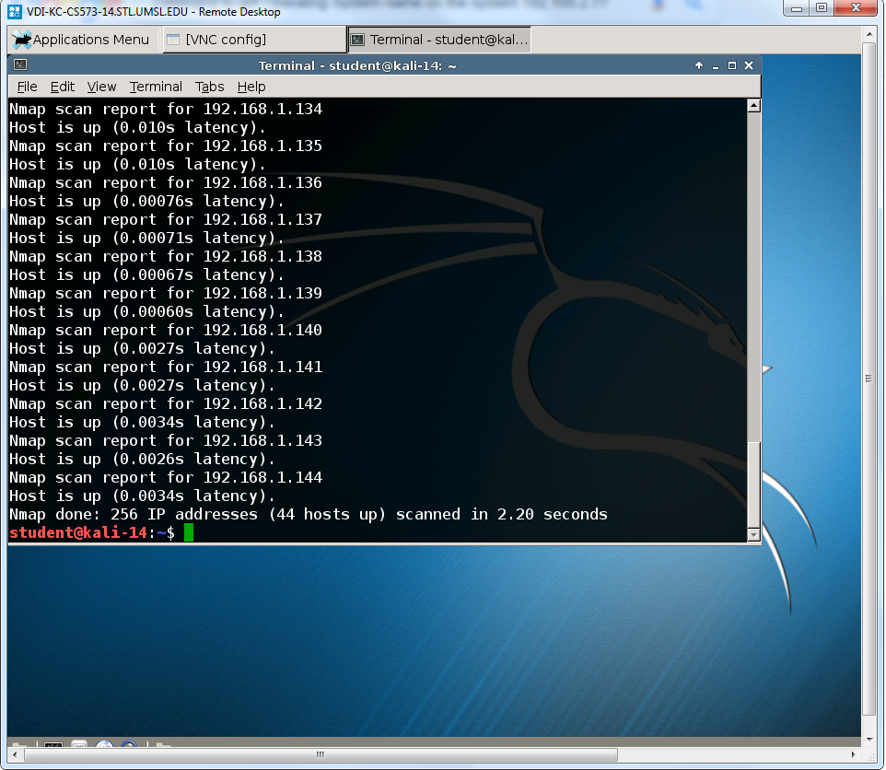

1. List all the **open ports** available on the **system 192.168.2.77** (1 point)

Ans: command:

**nmap 192.168.2.77**

Output:

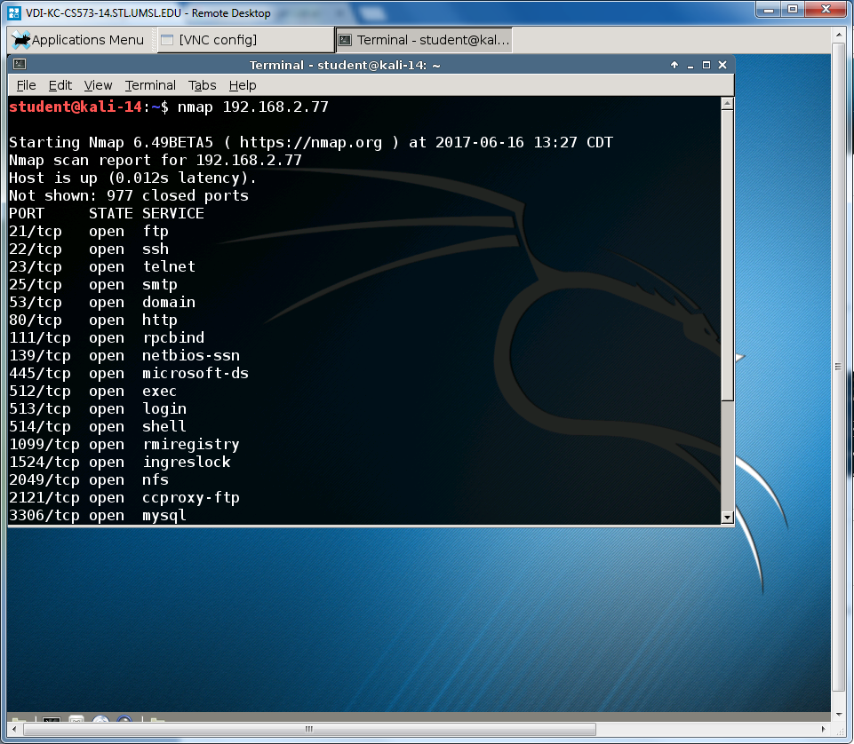

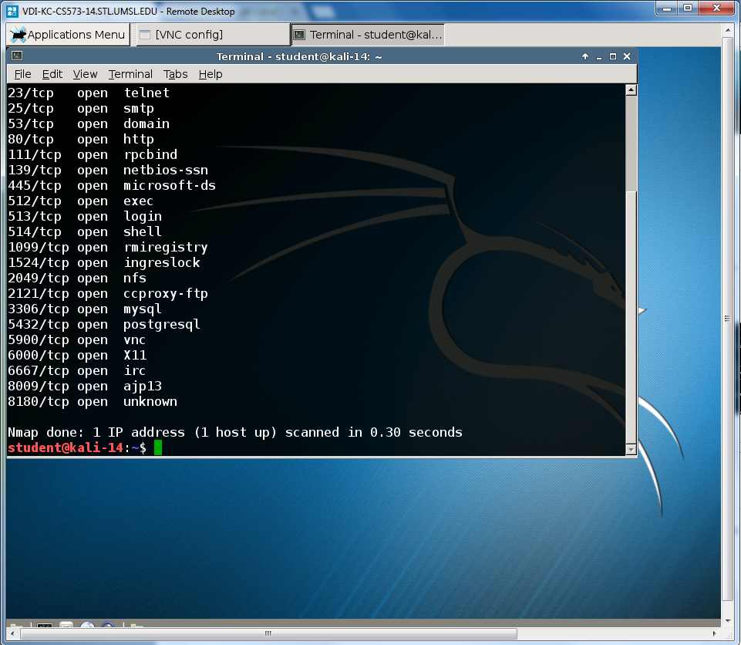

1. What is the **Operating System name** on the **system 192.168.2.77**? (Use banner grabbing method – telnet with port 80) (1 point)

Ans: command:

**telnet 192.168.2.77 80**

Output:

**Operating System name: metasploitable2**

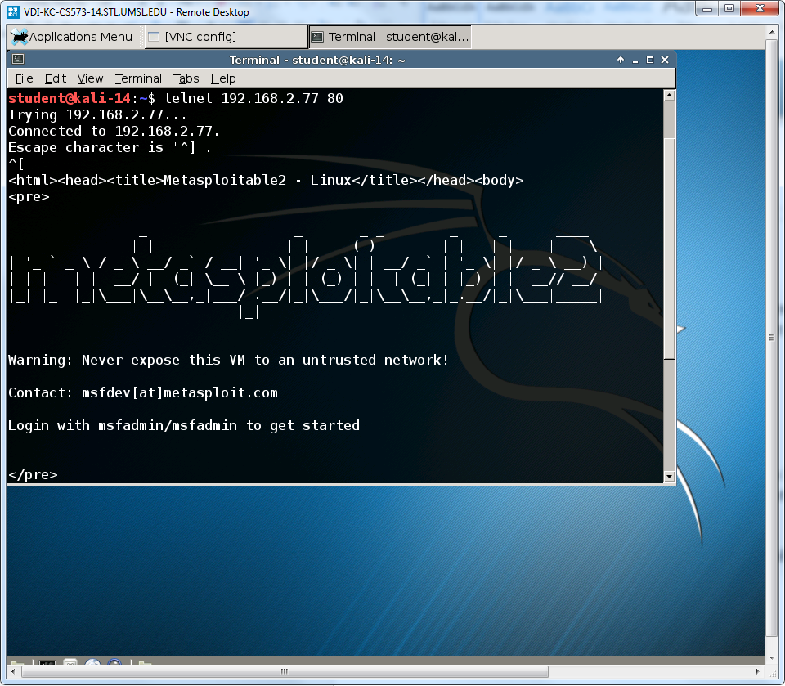

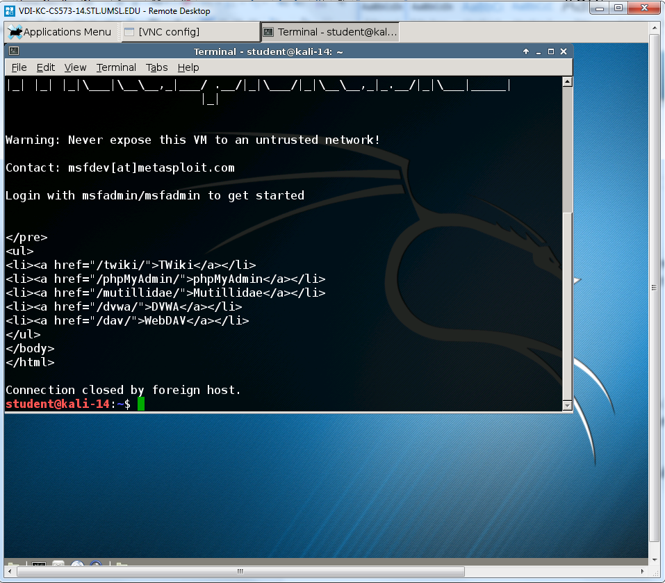

1. What is the **FTP server version** on the **system 192.168.2.77**?

( Use banner grabbing method – telnet with port 21) (1 point)

Ans: command:

**ftp 192.168.2.77 21**

Output:

service name and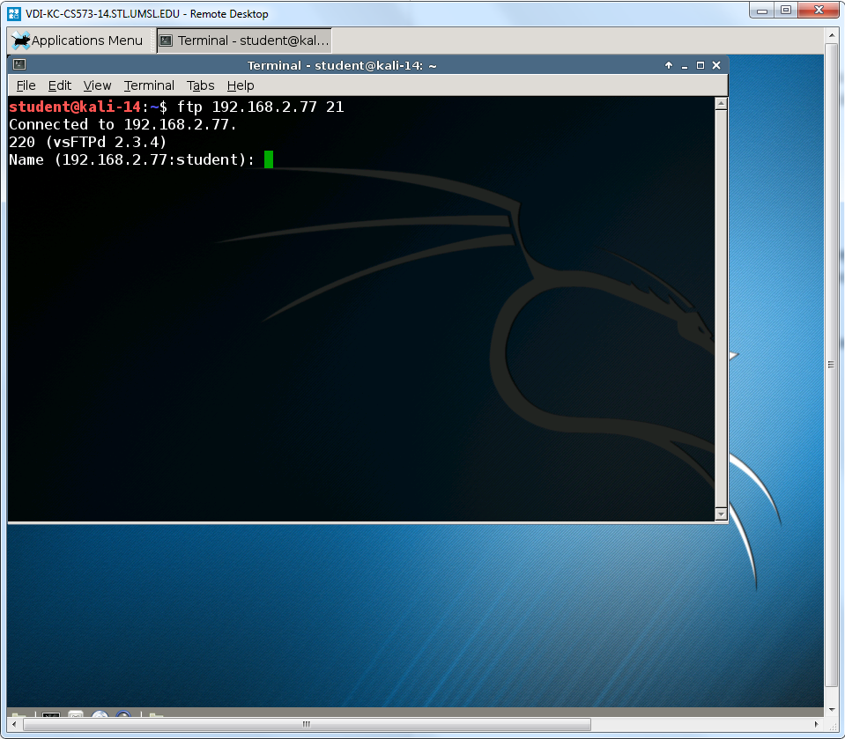 version number: vsFTPd 2.3.4